CENG 4513 Modeling and Simulation

2022-2023 Fall

Project Assignment 02

Simulation Development Project Report

1. We have selected the option number 5, which is “Library”, to simulate as a real-world problem from the given list.
2. Our group consists of Mehmet Kadri GOFRALILAR (180709005) and Hasan Ali ÖZKAN (180709020).
3. After observing the Muğla Sıtkı Koçman University Menteşe Library for a day and talking to the staff about data, the information we got was like following:

* Number of borrowed books daily (for October)
* Number of returned books daily (for October)
* Number of student entries daily (for October)
* Average study time
* Average registration time
* Average time spent for book borrowing process
* Average time spent for book returning process
* Average time spent for looking for specific books
* Number of total books
* Number of chairs (for studying purposes)
* Number of staff for processes
* Times of the maximum queue length for borrowing/returning books (in a day)
* Times that number of registration processes peak (in a term)
* Times of the study rooms reaching maximum capacity (in a term)
* Probability of a student finding the book they are looking for
* Probability of a student finding a spot in the study rooms

1. We have performed input data analysis for our data, and the results are like the following:

Borrowed_Book_Count:



Distribution Summary

Distribution: Uniform

Expression: UNIF(-0.001, 309)

Square Error: 0.054943

Chi Square Test

Number of intervals = 5

Degrees of freedom = 4

Test Statistic = 8.52

Corresponding p-value = 0.0784

Kolmogorov-Smirnov Test

Test Statistic = 0.118

Corresponding p-value > 0.15

Data Summary

Number of Data Points = 31

Min Data Value = 0

Max Data Value = 309

Sample Mean = 136

Sample Std Dev = 104

Histogram Summary

Histogram Range = -0.001 to 309

Number of Intervals = 5

Returned_Book_Count:



Distribution Summary

Distribution: Uniform

Expression: UNIF(-0.001, 157)

Square Error: 0.023725

Chi Square Test

Number of intervals = 5

Degrees of freedom = 4

Test Statistic = 3.68

Corresponding p-value = 0.461

Kolmogorov-Smirnov Test

Test Statistic = 0.151

Corresponding p-value > 0.15

Data Summary

Number of Data Points = 31

Min Data Value = 0

Max Data Value = 157

Sample Mean = 66.9

Sample Std Dev = 55.3

Histogram Summary

Histogram Range = -0.001 to 157

Number of Intervals = 5

Daily_User_Count:

metin içeren bir resim

Açıklama otomatik olarak oluşturuldu

Distribution Summary

Distribution: Normal

Expression: NORM(798, 636)

Square Error: 0.032638

Chi Square Test

Number of intervals = 3

Degrees of freedom = 0

Test Statistic = 4.52

Corresponding p-value < 0.005

Kolmogorov-Smirnov Test

Test Statistic = 0.208

Corresponding p-value = 0.12

Data Summary

Number of Data Points = 31

Min Data Value = 0

Max Data Value = 2.5e+03

Sample Mean = 798

Sample Std Dev = 646

Histogram Summary

Histogram Range = -0.001 to 2.5e+03

Number of Intervals = 5

But since we had data only for October, and we had to simulate a whole year, we generated a year’s data by applying weight coefficients to all months (weight coefficients are set according to the information given by the directorate of the library). The process is like following:

1) First, after generating new data with python code, we changed year order and turned 2022 to 2023 from January to August.

2) After that, we fixed the problems caused by day/date crash by arranging the weekdays and weekends with respect to a real calendar. The order of fixing is like following:

a. Find the day that respective month actually starts with,

b. Shift up the data in a way that the first day "n" in the simulated data is in the index of the real day,

c. Shift the over-written days down if the remaining days are not weekends,

d. Copy the data from last week's respective days if there are still empty days left.

3) And finally, holidays are set to 0.

These are the results of input data analysis of our one-year data:

Borrowed_Book_Count:

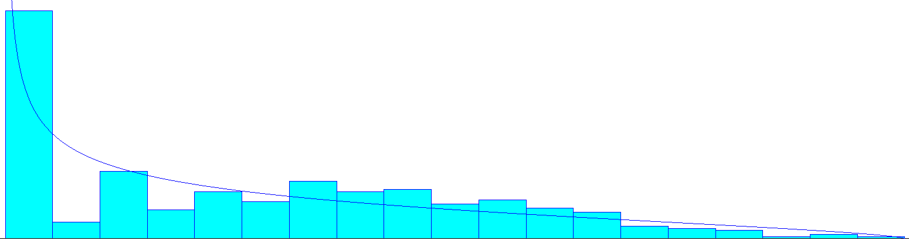

Distribution Summary

Distribution: Beta

Expression: -0.001 + 494 * BETA(0.611, 1.64)

Square Error: 0.017246

Chi Square Test

Number of intervals = 14

Degrees of freedom = 11

Test Statistic = 64.2

Corresponding p-value < 0.005

Kolmogorov-Smirnov Test

Test Statistic = 0.134

Corresponding p-value < 0.01

Data Summary

Number of Data Points = 365

Min Data Value = 0

Max Data Value = 494

Sample Mean = 134

Sample Std Dev = 122

Histogram Summary

Histogram Range = -0.001 to 494

Number of Intervals = 19

Returned_Book_Count:

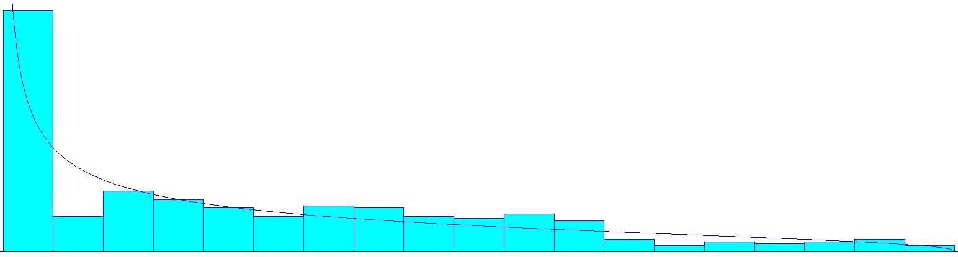

Distribution Summary

Distribution: Beta

Expression: -0.001 + 251 * BETA(0.503, 1.41)

Square Error: 0.006555

Chi Square Test

Number of intervals = 15

Degrees of freedom = 12

Test Statistic = 32.8

Corresponding p-value < 0.005

Kolmogorov-Smirnov Test

Test Statistic = 0.113

Corresponding p-value < 0.01

Data Summary

Number of Data Points = 365

Min Data Value = 0

Max Data Value = 251

Sample Mean = 66.1

Sample Std Dev = 64.8

Histogram Summary

Histogram Range = -0.001 to 251

Number of Intervals = 19

Daily_User_Count:

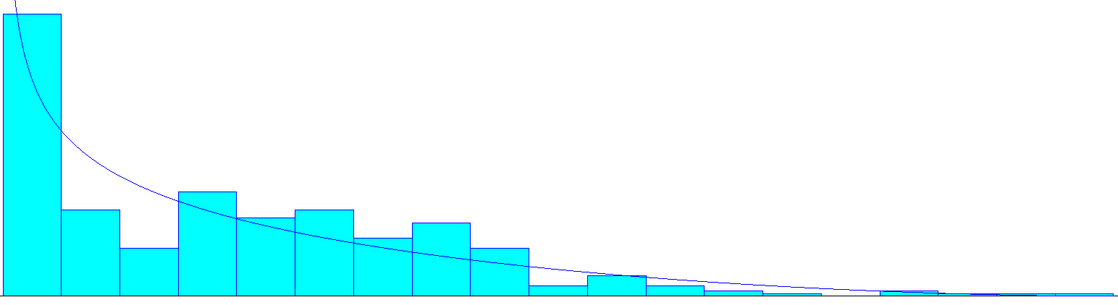

Distribution Summary

Distribution: Beta

Expression: -0.001 + 4e+03 * BETA(0.681, 2.73)

Square Error: 0.011385

Chi Square Test

Number of intervals = 12

Degrees of freedom = 9

Test Statistic = 56.4

Corresponding p-value < 0.005

Kolmogorov-Smirnov Test

Test Statistic = 0.134

Corresponding p-value < 0.01

Data Summary

Number of Data Points = 365

Min Data Value = 0

Max Data Value = 4e+03

Sample Mean = 799

Sample Std Dev = 762

Histogram Summary

Histogram Range = -0.001 to 4e+03

Number of Intervals = 19

Our system includes:

* Two different types of entity arrival types:

“Registered user” and “not registered user”

* Three processes (We’ve merged registering, borrowing book and returning book processes into a single process named desk process by using assignment for several reasons such as shared resource, shared queue and etc.):

“Desk”, “looking for book” and “study”.

* One Queue limit:

Desk queue is limited by using “**hold**” and making the queue at length of maximum 10, making the rest wait in a waiting room, therefore queue for every process that is handled in desk (registration, book borrowing and book returning) is shared limited.

* Routes and Stations:

go_to_borrow_station => borrow_station

go_to_return_station => return_station

go_to_study_station => study_station

go_to_desk_station_after_registeration => desk_station

go_to_exit_station => exit_station

go_to_desk_station_after_book => desk_station

go_to_additional_action_station_after_book_not_found => additional_action_station

go_to_additional_action_station_after_action => additional_action_station

go_to_additional_action_station_after_desk => additional_action_station

go_to_borrow_station_after_additional_action => borrow_station

go_to_return_station_after_additional_action => return_station

go_to_study_station_after_additional_action => study_station

go_to_exit_station_after_additional_action => exit_station

* Failures:

Local data is uploaded to database twice a day, once in the middle of the working hours and once more in the end of the working hours, which takes approximately 3 minutes. During this procedure, no processes are allowed in the desk.

* Assignments

Assign_Registeration

Assign_Borrow

Assign_Return

These three assignments are done in order to distinguish the processes that are done in desk and arranging their process times.

* Decisions:

+Decide_on_Action = [25.9%, 25.9%, 43.2%, ELSE] [Borrow, Return, Study, EXIT]

+Decide_on_Additional_Action = [10%, 10%, 16.66%, ELSE] [Borrow, Return, Study, EXIT]

The probabilities of these two decisions are arranged according to the average counts of the processes done by users.

+Is_Registered = EntityType

This decision is for separating the entity types in order to decide whether they need to be registered or not.

+Is_Book_in_Library = 95%

Since whether the book is in the library or not is not a deterministic problem, we have calculated a probability from the following formula that we have deducted:

IsBookInLibrary = ((total published books in the library - currently borrowed book count) / total published books in the library)

* Tallies and Recording to output files:

We used ‘**Record**’ to give the output for start times of processes done in the desk in the file named “***1_Staff.xlsm***” along other data given by the ARENA itself.

* Run time statistical representations:

One year is approximately equal to 250 work days, therefore our simulation is repeated 250 times for 8 hours.

1. “Queue lengths and waiting time vary from time to time and almost impossible to predict using a short observation data” said the Directorate of Library. Therefore, we couldn’t extract the real data for queue lengths and waiting time, so we couldn’t compare the simulated queue length vs. real queue length and simulated waiting time vs. real waiting time. Simulated served user count and the real served user count is compared. But since demo version of ARENA only allows 150 entities to exist in the system at once, the arrival counts are multiplicated with a coefficient of approximately 1/5, also the user entrance rate is divided by the same coefficient, therefore the ratio is intact. We can see that the entrances are finished before the working hours end, therefore most of the users can complete their processes, like in the real life. Hence, we can conclude that the arrival rates are matching. Also, average queue length is believed to be close to the real-world situations according to the data acquired by the approximations of the library staff.

Summary report of the simulation when there is only 1 library staff member (which is the case in Muğla Sıtkı Koçman University Menteşe Library) is in the file named “**1_Staff.xlsm**”.

1. We added a second staff member to the system since desk queue can be quite long (wait room actually). After adding the second staff member, we see that the average wait times, average queue lengths and other problematic aspects are much better in the desk process. Summary report of the simulation when there are 2 library staff members is in the file named “**2_Staff.xlsm**”.
2. The Arena (*.doe) files are attached in the same file directory as this report.